Project Planning Phase
Date | 04 September 2026
Student Name | Pulibanti Tejavani
Project Name | Metro Ticket Generating System
Maximum Marks

Product Backlog, Sprint Schedule and Estimation
Sprint | Functional Requirement (Epic) | User Story / Task | Story Points | Priority | Student Name
Sprint-1 | Foundation | Create ServiceNow application, Metro Station Details table and required fields. | 6 | High | Pulibanti Tejavani
Sprint-2 | Ticket Booking | Create Book a Metro Ticket catalog item and configure booking variables. | 6 | High | Pulibanti Tejavani
Sprint-3 | Automation & Portal | Configure fare calculation, UI policies, Service Portal and QR widget. | 6 | High | Pulibanti Tejavani
Sprint-4 | Testing & Security | Perform functional testing, data validation, access control and documentation. | 4 | High | Pulibanti Tejavani

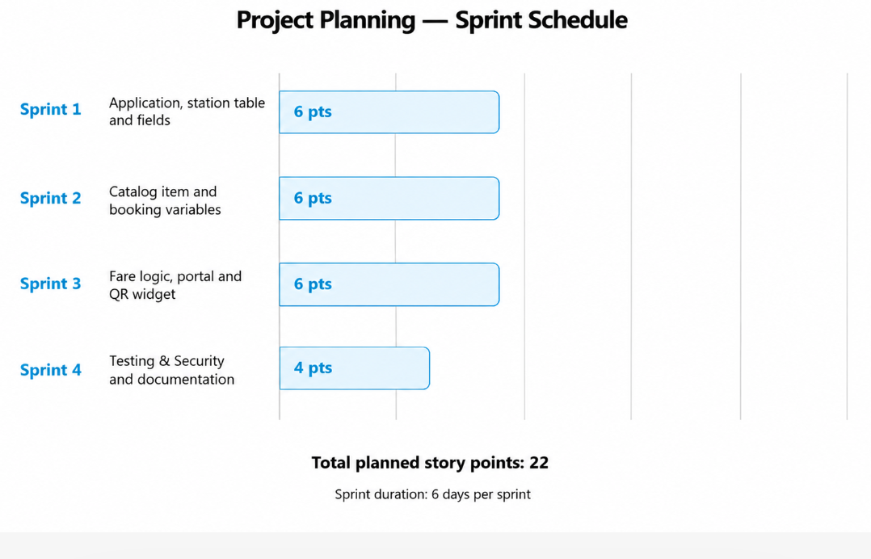

Figure 1: Sprint schedule and story-point representation.
Project Tracker
Work Item | Status | Validation
ServiceNow Application | Completed | Metro ticket application created and configured.
Metro Station Details Table | Completed | Station and fare information configured.
Catalog Item | Completed | Book a Metro Ticket item created.
Booking Variables | Completed | Starting station, destination, journey type and passenger count configured.
Fare Calculation | Completed | Fare dynamically calculated based on route and passenger count.
UI Policies | Completed | Payment-related field visibility configured.
Service Portal | Completed | Metro ticket booking page made available through the portal.
QR Widget | Completed | QR code generated and displayed through the widget.
Testing | Completed | Booking flow, fare calculation and QR generation validated.

